**How to set up your new Flagstaff High School ParentVUE account**

*This is for first time activation. If you forgot your password, on step 6 click on “Forgot Password.”

1. From your device go to [www.fusd1.org](http://www.fusd1.org). Select Flagstaff High School from the “Select a School” tab.



1. From the FHS home site, choose “Resources” and then “Parents.”

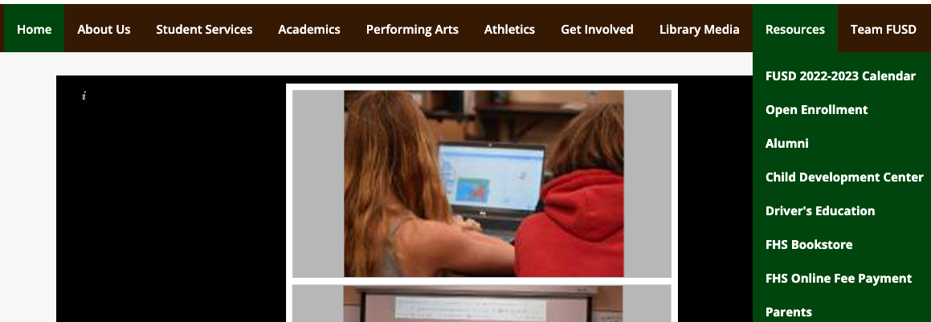

1. On the left hand menu, you will choose ParentVUE.

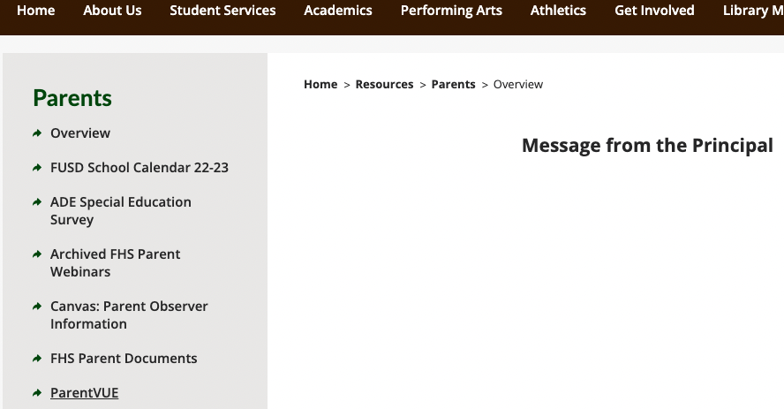

1. Click on the link.

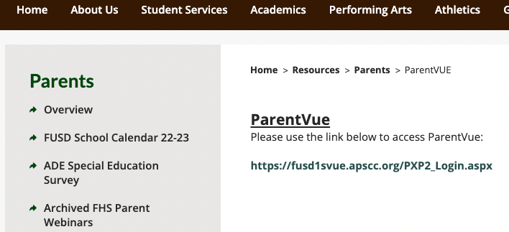

1. Select “I am a parent.”

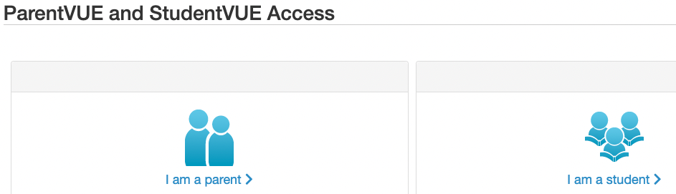

1. Choose “More Options” and select “Activate Account”

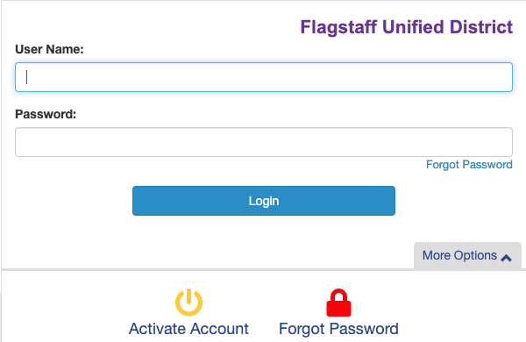

1. Read the Privacy Statement and Accept terms.
2. You will need an “Activation Key” to complete your setup, which is provided by the FHS Front Office.
3. If you have any other questions or issues, please contact the FHS Front Office.